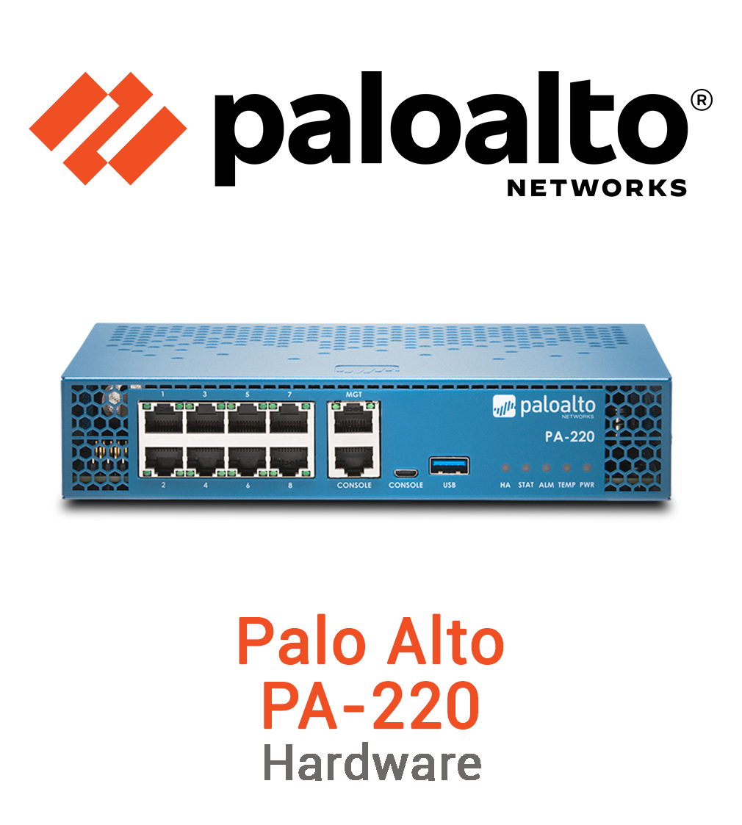
URL Filtering
Marvin Boonnantakul
Purpose:
The purpose of this lab is to configure the pa 220 firewall inside the web GUI to verify URL filtering inside the network. The goal of this lab is to have control of the web access of the end user that will now be controlled by creating URL filtering profiles, assigning redirect pages to specific website categories, and applying the profile to security policies governing the outbound traffic. The result of this lab is to be able to illustrate the use of URL filtering, enhancing network security by restricting access to inappropriate or malicious content, by monitoring user’s activities and enforcing browsing policies.
Background:
This lab is a continuation of the pervious lab where the administrator implements the SOHO configuration for small offices or home networks. This URL filtering lab helps secure the SOHO configuration network and its end user by controlling and monitoring web traffic on specific content categories.
To configure this URL filtering lab, begin with verifying the firewall’s URL filtering license and ensuring that it is up to date to continue the lab. Once the license is verified, a new URL filtering profile can be created inside of the security profiles section. Under each web category such as adult, gambling, or social networking the network administrator has the ability to specify a allow, alert, block, override, or continue accordingly to the administrators configurated security and organization requirements. Furthermore, URL can be specifically configured for certain websites from its predefined classification configurations. To ensure all user traffic for the internal network passes through the URL filtering configuration, the profile must be applied to an outbound security rule. Lastly the configuration must be committed to changing the firewall.
The Palo Alto PA-220 firewall taps into the PAN-DB URL Filtering database, sorting countless sites into groups using their reputation, material, and threat score. Admins have the option to build private site groupings for domains that don’t match usual types. With tailored setups like these, companies get tighter control over web access, shaping rules that reflect actual work needs and usage guidelines.
Setting up URL filtering works well alongside tools like intrusion blocking, virus checks, or encrypted traffic inspection. These combined safeguards form a solid shield that reduces online risks coming in or going out.

Lab Summary: This lab showed how to set up URL filtering on a Palo Alto PA-220 using the web interface. First, we checked if the device had an active license for this feature, then updated the PAN-DB info so it could recognize current sites. Next came building a custom filter profile, where different reactions were assigned depending on site types. That setup got linked to an outgoing traffic rule to take effect. In short, this configuration illustrates how cutting off risky websites protects networks better than blocking threats but also keeping work environments focused and within policy lines. It reveals how URL filtering highlights features like SSL decryption, accurate PAN DB categorization, to enforce deeper, and more reliable control over encrypted and user specific traffic.
Problems: In the PA-220 filtering test, Bing didn't show the usual block screen however, it loaded the override page's IP instead of the page. Furthermore, the firewall’s root CT was not recognized by the browser.
Lab Commands: N/A
Network Diagram with IP’s: 
Screenshots:
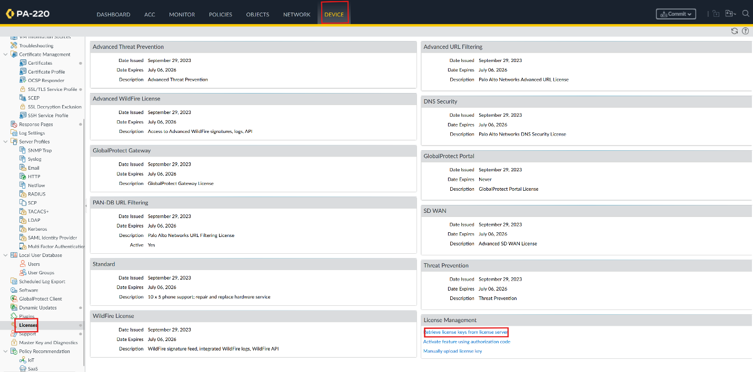
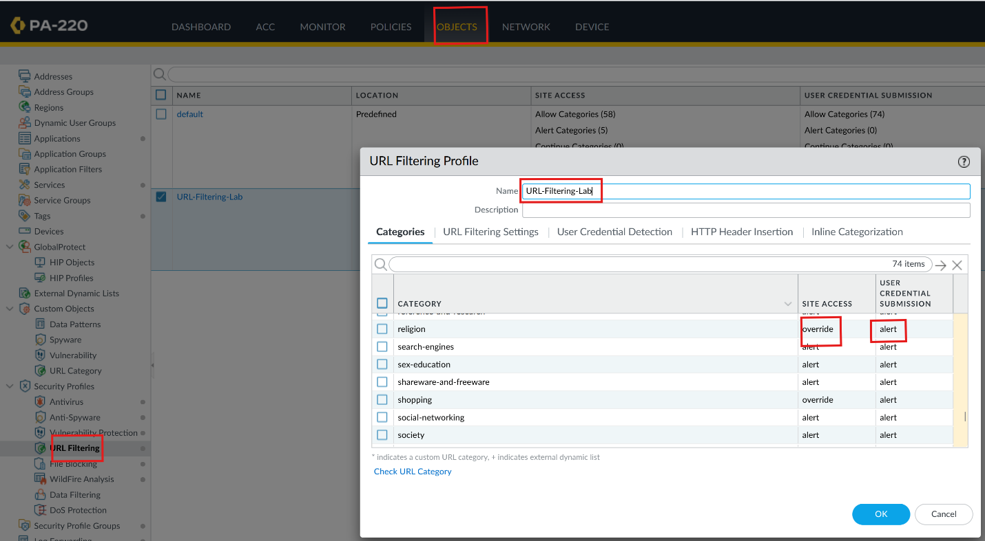
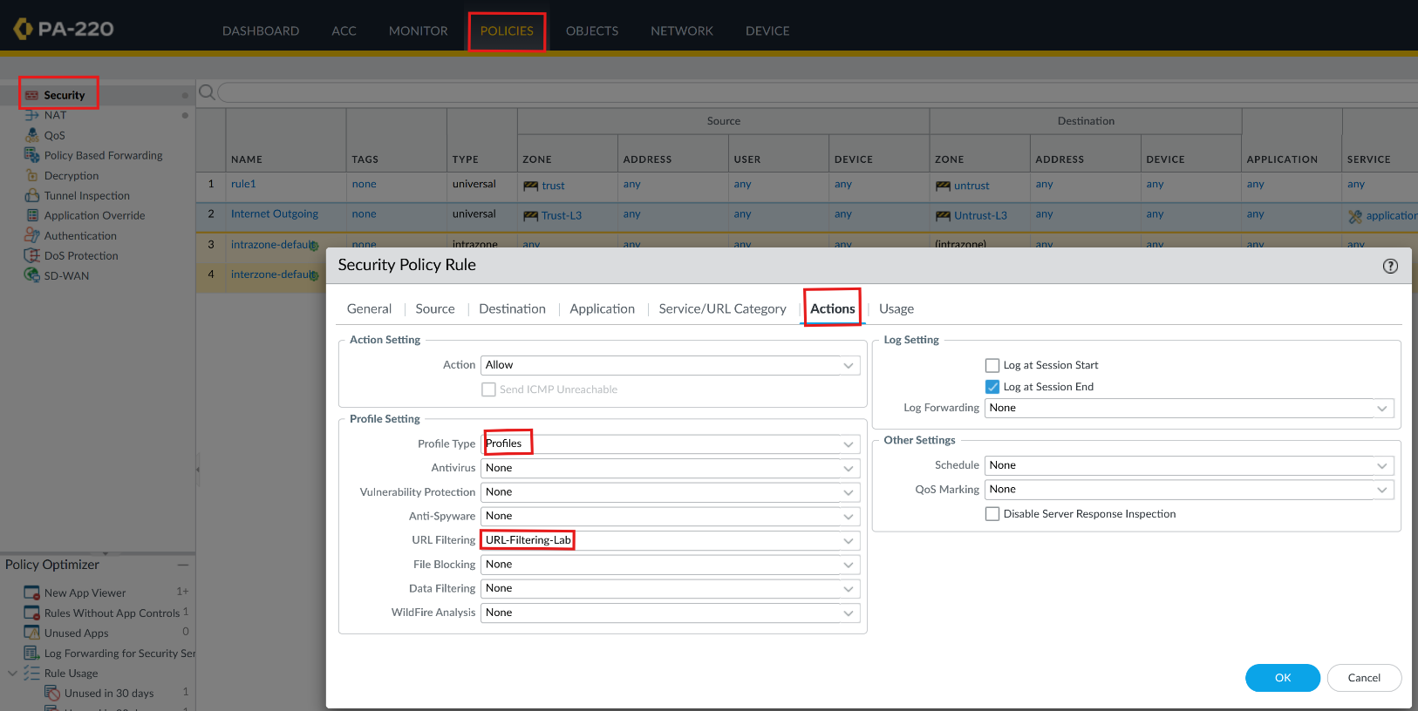
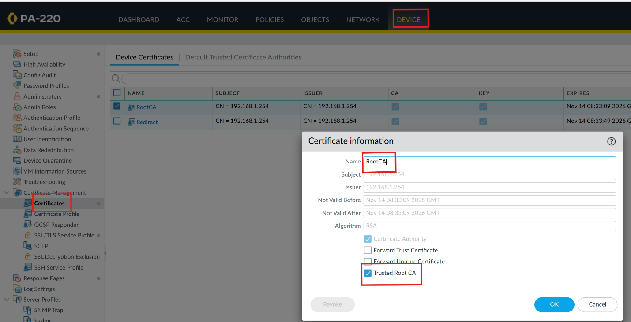
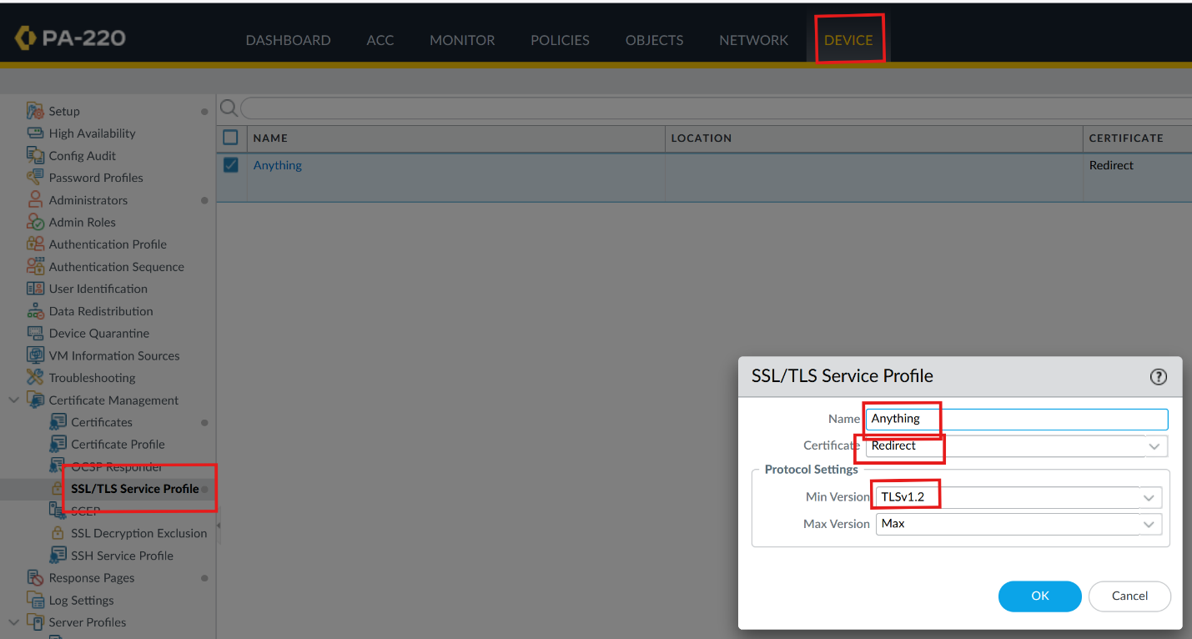
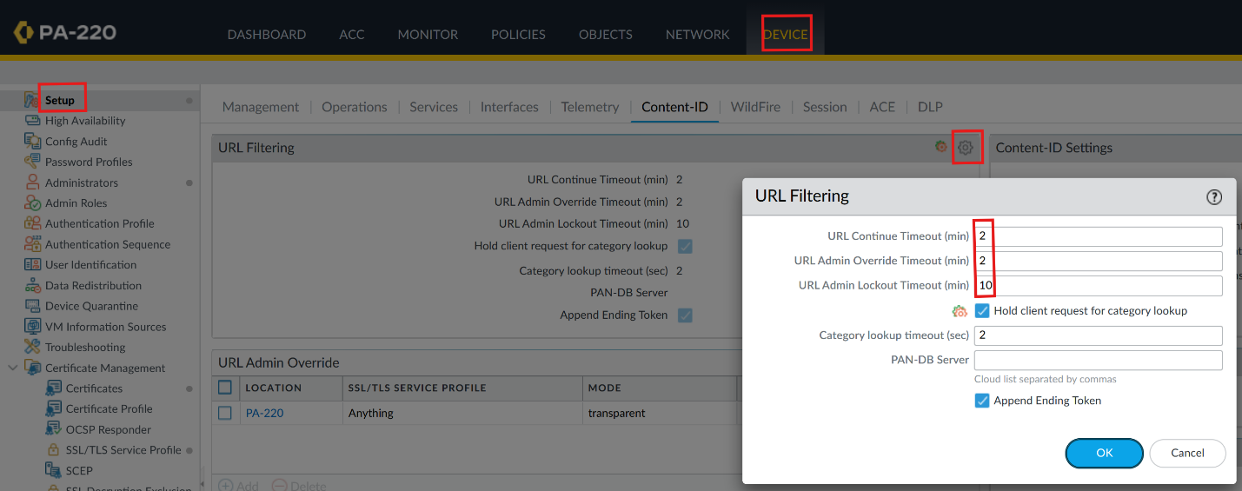
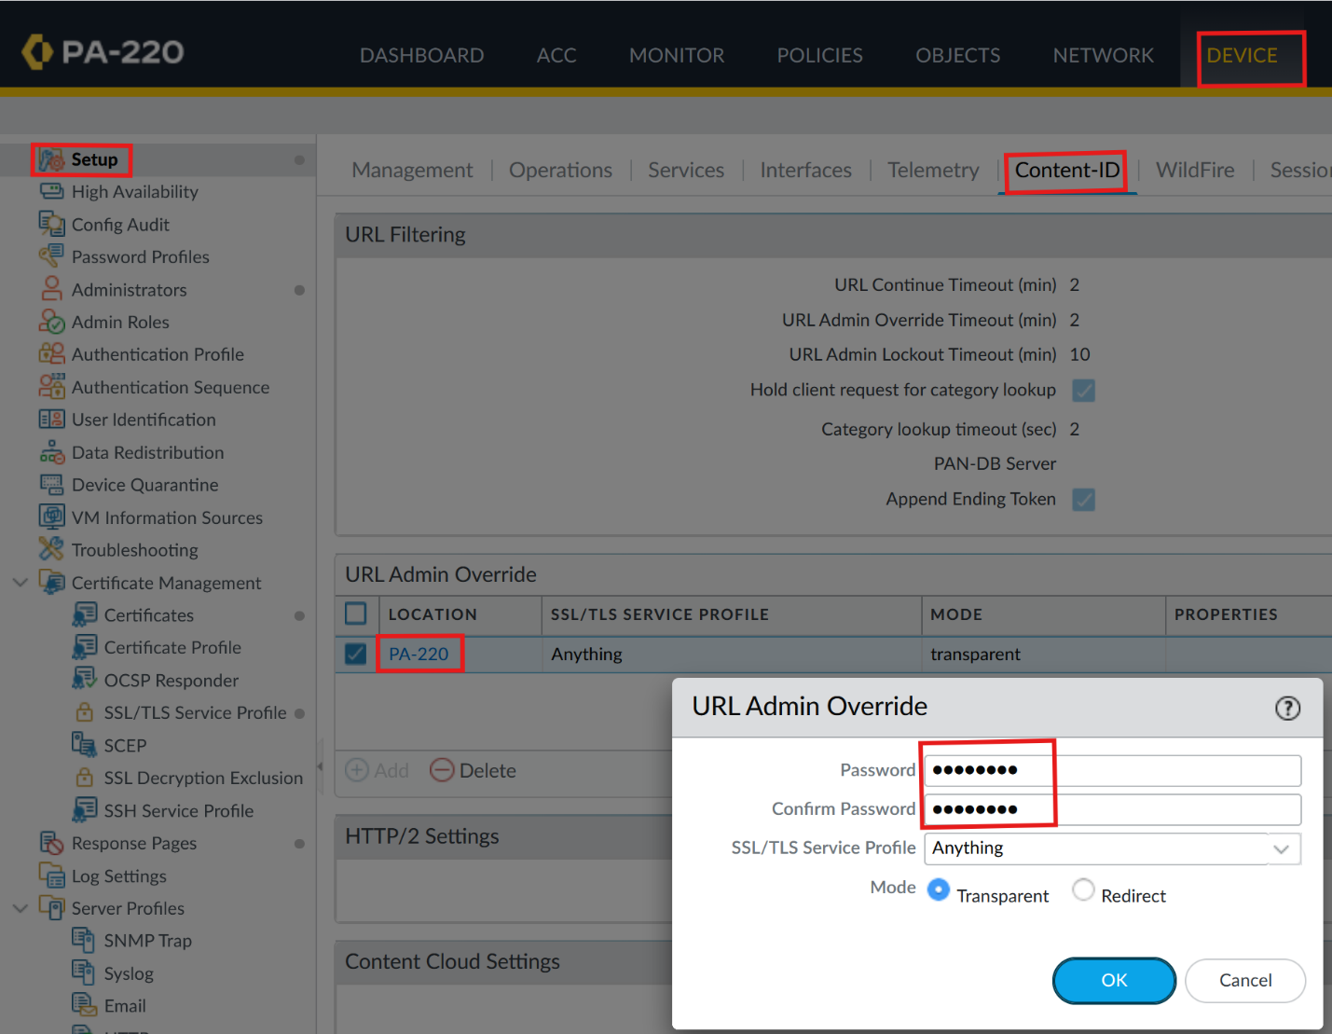
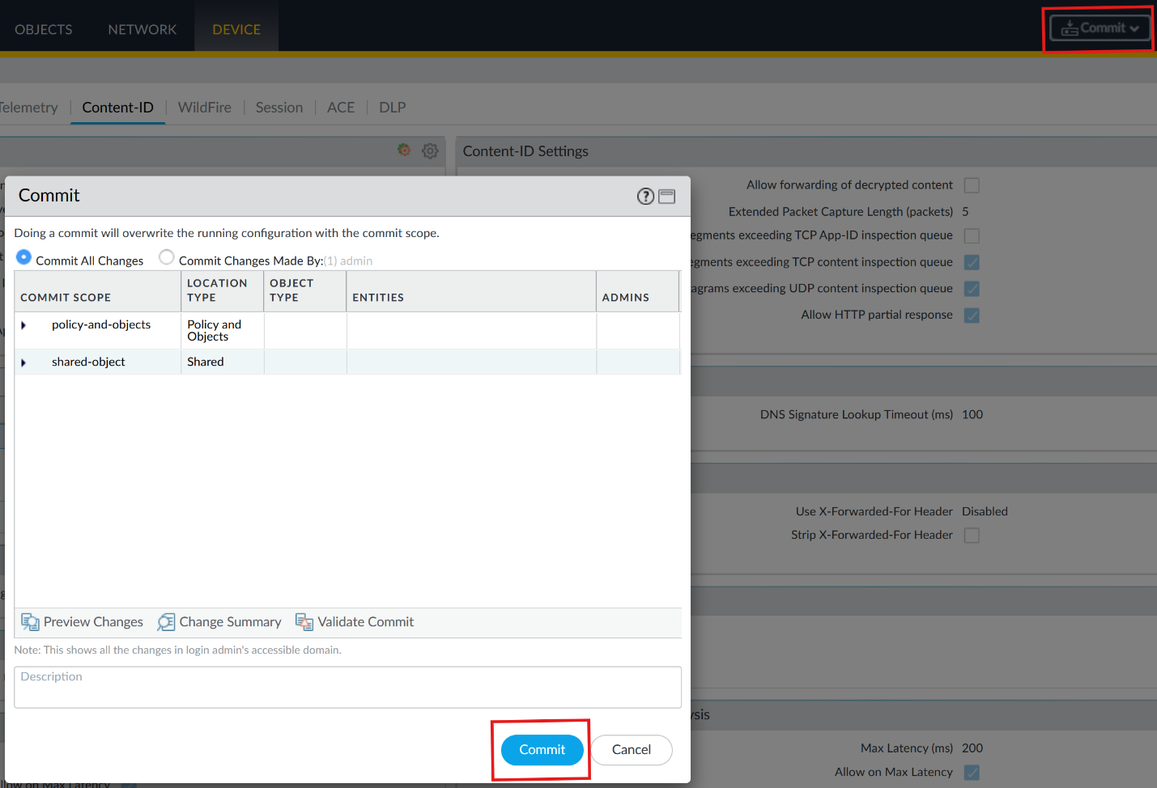

Sign off:
